EventRequest Table (I m using Oracle and Sql Developer Client)
- CREATE TABLE Statement
CREATE TABLE EventRequest
(
EventNo varchar2(8) CONSTRAINT EventNoabsent not null,
DateHeld date CONSTRAINT DateHeldabsent not null,
DateReq date CONSTRAINT DateReqabsent not null,
FacNo varchar2(8) CONSTRAINT FacNumberabsent not null,
CustNo varchar2(8) CONSTRAINT CustNumberabsent not null,
DateAuth date,
Status varchar2(30) CONSTRAINT Statusabsent not null,
Estcost decimal(10,2) CONSTRAINT Estcostabsent not null,
Estaudience integer CONSTRAINT Estaudienceabsent not null,
BudNo varchar2(10),
CONSTRAINT eventPK PRIMARY KEY(EventNo),
CONSTRAINT facnoFK1 FOREIGN KEY(FacNo) REFERENCES Facility,
CONSTRAINT custnoFK FOREIGN KEY(CustNo) REFERENCES Customer,
CONSTRAINT ValidRequestStatus CHECK(Status IN ('Pending','Denied','Approved')),
CONSTRAINT EstaudienceCheck CHECK (Estaudience > 0)
);

- Run the above command
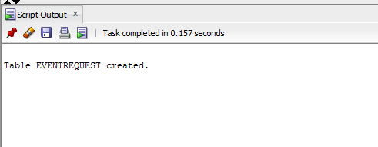
- Insert rows into it

Using example insert statements given for the assignment.

- Table data
